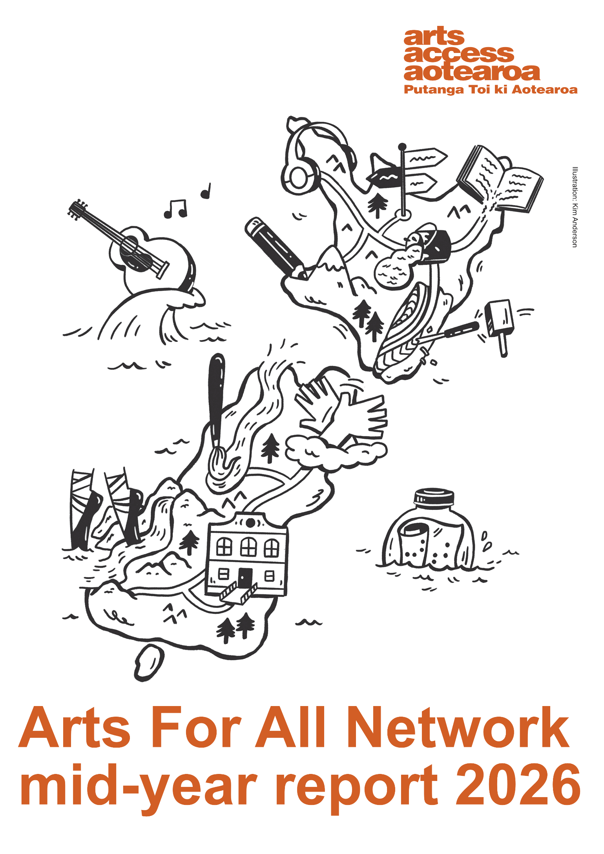

The artwork at the start of the report was commission from disabled artist Kim Anderson (kimcandraw.com, @kimcandraw). The black and white line drawing shows Aotearoa New Zealand itself being created by accessible arts.

Headphones hang over the top of Te Rerenga Wairua/Cape Reinga, representing relaxed events and sensory access. A path travels south, linking wayfinding signage with an open book perched on the tip of the East Cape. Words from the book pour onto the path to Lake Taupo, formed from paint spilling from a pot. A pencil draws Mount Taranaki, and a whao whakairo carves the southeast coast of Te Ika-a-Māui/North Island.

From the top of Te Waipounamu/South Island a paintbrush creates a winding river. Two hands sign New Zealand Sign Language. The path continues south to an accessible building, then loops west to a pair of dancing ballet-slipper clad feet forming the rivers of Fiordland. In the water, a guitar with musical notes is catching a wave, and a message in a bottle, the word art spelled in Braille, bobs along in the water.

Orange text along the bottom reads Arts For All Network mid-year report 2026.
Arts For All Network Report 2026

Overview
Between December 2025 and February 2026, the annual Arts For All Network survey was sent out to all Network members, asking them questions about their accessibility work and progress in 2025. This annual survey provides a way for Network members to give feedback, make requests and share thoughts, and for us to see how the sector is progressing towards increased accessibility.
Your answers shape how we work and plan to best serve you. This is the report of our findings and how we are putting your feedback into action.
A low number of members filled out the survey, meaning that not all viewpoints are represented here. This report combines the answers of the people who responded to the survey, and notes and feedback taken throughout 2025, to give an overview of what members are thinking, feeling and communicating.
Low engagement with the survey means that statistics can’t be provided for the report this year. Far less people answered the survey than the previous year, and we didn’t receive enough answers to compare numbers with last year.

What the members tell us
As in last year’s report, members describe engaging in accessibility as both rewarding and challenging. Many people express genuine enthusiasm, noting that even small changes can make a significant difference and enrich artistic, professional and community practice.
The process is often described as eye-opening: it encourages people to think beyond their own experiences, learn from disabled communities and create more inclusive environments.
Positive collaborations, particularly with supportive organisations and communities, have helped build confidence, inspire new approaches and reinforce that accessibility is an ongoing journey of learning rather than a fixed endpoint.
There are also ongoing structural and practical barriers. Despite these obstacles, there is a strong sense of gradual progress and commitment to improvement, with slow but meaningful changes over time. Although setbacks can be disheartening, successful initiatives are highly impactful and affirm the importance of the work.
Overall, accessibility efforts are seen as vital, community-enhancing, and worth the ongoing effort, even when the process is complex, resource-intensive, and at times overwhelming.

Membership
The Arts For All Network had 1,101 members by the end of 2025.
Opportunities for online connection have enabled more engagement in regional communities. The Network includes a wide range of organisations: GLAM institutions, disability service providers, theatre companies, festivals, councils, universities, venues, creative spaces and independent artists. Anyone with any connection to the arts, who wants to see accessibility in the arts increase, can belong to the Network. This means a wide range of perspectives, experiences and knowledge is represented.
Members can connect in whatever way serves them best, through one-on-one connection, attending online and in-person sessions, using online resources and connecting with each other.

What respondents achieved in 2025
- Many members focused on adding or improving accessibility information for their space or event, including improving accessibility with their marketing and communications to ensure more people had access to vital information about engaging.
- Accessible programmes of events (e.g. NZSL interpreted, audio described, and relaxed events) were added or maintained.
- Many members reviewed the accessibility of an existing process or system and worked to make improvements. Rather than introducing a new programme, many members recognised the importance of improving accessibility from the baseline. This approach felt more achievable within limited budgets and capacity, and felt more permanent.
- Some members made infrastructure improvements, from minor to major. Improved signage and wayfinding through to larger changes to buildings removed barriers in the built environment.

How respondents increased accessibility in 2025
Increased personal knowledge, especially through learning directly from Deaf and disabled people, and access to practical advice, encouragement and useful resources, were important for starting and progressing accessibility.
“We don’t know what we don’t know” was a common sentiment, meaning that knowledge is key to identifying barriers and finding solutions. Learning directly from Deaf and disabled people was the most impactful. Opportunities to ask questions, receive guidance and build confidence through supportive networks was vital: in particular, connections with Deaf and disabled communities, accessibility practitioners and other Network members doing accessibility work.
Alongside this, funding, planning and organisational commitment played a critical role. Grants, council funding and targeted initiatives (e.g. accessibility funds) make it possible to implement tangible changes, while embedding accessibility into strategic plans and policies help ensure it is sustained over time.
Incremental approaches such as breaking work into manageable steps and starting small with the aim to grow, combined with staff buy-in, internal expertise and collaboration with partners, further support progress.
Practical improvements, such as better communication, clearer wayfinding, accessible digital content and purpose-built spaces, are often made possible when these factors align, highlighting that both resources and a supportive organisational culture are key to advancing accessibility.

Key barriers
Members want to commit more strongly to accessibility but face barriers to increasing accessibility.
Limited funding, time and staffing, and competing organisational priorities, frequently slow progress. There are also challenges around internal systems, communication gaps and inconsistent commitment from others, including resistance or lack of understanding about the value of accessibility. Some note frustrations with tokenistic engagement, where feedback is sought but not meaningfully implemented, and difficulties balancing diverse accessibility needs across different communities.
Some members pointed out that funds were available but not allocated to accessibility within their organisations. With funds going elsewhere first, new access initiatives and projects are hard to grow, and it’s difficult to increase access for existing projects. A strong, full-team commitment to funding accessibility as a regular core operation, rather than an add-on that gets cut in lean times, would support projects to stabilise and grow.
Lack of knowledge was also a barrier. Not knowing who to talk to, how to get the knowledge needed, where the resources were, or how to start or progress was cited as the stumbling block for many Network members.
Fear of getting it wrong, from low understanding of Deaf and disability culture to being unsure of how to make connections, also continues to get in the way of experimentation and trying new things.

Vision for arts accessibility
The dream for Network members is for arts accessibility to be embedded across Aotearoa, where everyone can participate as artists, audiences, staff and leaders without barriers.
- Born accessible: Every event, programme, venue, website and communication is designed to be accessible from the outset. Additional access programmes and initiatives complement strong baseline access rather than being a layer over the top of an otherwise inaccessible initiative. Regular NZSL interpreted, audio described, captioned, relaxed, sensory-friendly and Easy Read experiences are available as standard.
- Permanent accessibility: A shift from reactive, one-off or short-term solutions to a gradual and deep growth in core accessibility. Accessibility becomes embedded in organisational culture, recognised as a human right and a core measure of best practice rather than an optional initiative.
- An ecosystem of accessibility: More accessible venues and infrastructure, sustainable and dedicated funding and staffing, and environments where people can independently discover, book, attend and participate in arts experiences. Clear and accessible online information and improved assistive technologies support full access to digital spaces.
- Deaf and disabled leadership: Greater representation of Deaf and disabled artists, writers, performers and staff, with meaningful employment and leadership opportunities. Strong, trusting relationships with Deaf and disabled communities through co-design practice and programming, outreach and workshops. More opportunities for disabled-led artistic development.

Looking forward
Members want Arts Access Aotearoa to continue its strong advocacy, advice, training and networking while expanding opportunities for connection, collaboration and practical support.
Key themes
- Continue existing support: Maintain the high-quality advice, advocacy, venue, resource and event reviews, mentoring, workshops and one-to-one support.
- Networking and connection: Create more opportunities for in-person and online hui, regional gatherings and peer learning between organisations committed to accessibility. Keep organisations informed, facilitate conversations, and provide spaces where people can share experiences, problem-solve and learn from each other.
- Training and knowledge sharing: Provide practical workshops, resources and guidance on emerging topics like accessible technology and inclusive event design. Offer access to templates, policies, accessibility resources and examples of best practice that organisations can adapt.
- Community engagement: Help organisations build stronger relationships with Deaf and disabled communities through collaboration, consultation and feedback.
- Funding support: Share grant opportunities, funding sources and advice to help organisations improve accessibility and deliver accessible programming.
- Advocacy and sector leadership: Continue to champion accessibility, raise awareness, and promote the importance of arts, creativity and inclusion to key decision-makers and funders.
- Professional development: Continue to create opportunities for Deaf and disabled artists and arts workers, and support organisations to build accessibility knowledge across all staff.

Findings
Many members shared about the value of increasing their own knowledge by learning from Deaf and disabled people, other Network members and their communities. As a result, the focus of the Arts For All Network programme, information and support in 2026 is growing knowledge together.
Arts Access Aotearoa is working to ensure members can access the knowledge they need to get started and progress with accessibility. Building on last year’s theme of “Small changes over time can have a big impact”, we aim to help members build their knowledge with confidence to recognise barriers, identify what voices, bodies and experiences are missing, and understand how to take steps to start or increase arts accessibility.
Our guiding whakataukī for 2026 is: Whaiwhia te kete mātauranga / Fill the basket with knowledge. This whakataukī has set the direction for all our activities this year. It supports the Network members’ desire to increase their accessibility knowledge and have a firm base of understanding before continuing to add projects.

Our progress so far
We compare our work from 2025 with our current 2026 mahi, and show how we’ve shaped our work and programmes based on your feedback.

Workshops and training
In 2025, we completed pilot programmes for two training workshops: accessibility responsiveness training and front-of-house accessibility training. Both disabled-led workshops were created in response to requests from Network members to support deep, whole-of-organisation accessibility upskilling or to provide training for front of house and customer-facing teams to welcome Deaf and disabled visitors. Nine front-of-house accessibility workshops are scheduled in eight regions for 2026, with four sessions delivered as end of July 2026. Both trainings are now available on demand.

Regional engagement and connection
Online hui continued in 2025, with ten monthly sessions. In 2026, we’ve added two new online programmes.
Online Q&A sessions allow Network members to learn directly from Deaf or disabled artists. They can submit questions and get the direct, lived experience they need to increase accessibility with true collaboration and guidance.
Drop-in learning sessions were launched in April 2026, in response to members asking for more opportunities for practical “how-to” sessions. These open Zoom sessions offer instruction on specific accessibility topics or practices, and then invite questions and collaboration in a collective, open hui environment.
A total of 17 online sessions are scheduled for Network members in 2026, increasing from 10 sessions in 2025.
Regional in-person hui continue in 2026, with the number of regional visits increased to nine. Based on demand, we added a third South Island region visited (Queenstown and Lake District) and we continue to work toward expanding our in-person presence in other regions. If you’d like us to visit your region, please get in touch.

Sharing opportunities and information
The Arts For All Network News, a short monthly newsletter specifically for the Arts For All Network, was started in February 2026. The newsletter shares information about the next month’s upcoming activities and offers simple, practical and actionable accessibility advice. Through the regular newsletter we aim to ensure the Network has easy and timely access to the many opportunities, hui, workshops and learning sessions available.

Resources
Our 2026 programme page was developed and launched at the start of the year to share the full year’s calendar of events, allowing Network members to have a better understanding of what’s available to them throughout the year and fit engagement more easily into busy schedules. We are also putting website architecture improvements in place to make our website more navigable and accessible for assistive technology.

Member-to-member learning opportunities
Members expressed the desire to learn and connect more with each other. The number of open hui has increased this year, shifting from a focus on one-on-one individual advisory to collective learning sessions where Network members from across Aotearoa can learn together, and work to increase accessibility more broadly. Spotlight sessions were introduced for in-person regional hui, allowing multiple people the opportunity to share their mahi, rather than one single presenter. This model aims to fit serve our Network, made up of members from diverse backgrounds, roles, sectors and connections into the arts.

Sector engagement
Every year we take part in or facilitated accessibility panels, presentations and lectures. We presented at the 2026 Performing Arts Network New Zealand (PANNZ) Arts Market. This year we added a panel discussion at Te Muka Toi, Te Muka Tākata Creativity and Culture Hui in Queenstown in a first-time engagement with that region.
Still to come are lectures and field trips at Victoria and Massey universities in Wellington. The public platforms allow us to share the importance of arts accessibility and the services provided by Arts Access Aotearoa to wider audiences in the arts sector, including to funders, key decision-makers, and large institutions. If you’d like us to present at your event or conference, contact details are at the end of the report.

Conclusion
This 2026 report shows a sector thirsty for knowledge about accessibility in the arts. Despite continued funding uncertainty and sector instability, accessibility continues to move forward. Working in partnership, Deaf and disabled people and non-disabled people together, has led to the most lasting changes and strongest plans for sustainable accessibility. The Arts For All Network will continue to offer knowledge and learning opportunities, filling the basket with knowledge for Network members, and supporting them to fill the basket of others.
Arts Access Aotearoa builds our planning and direction from the feedback provided by our members. Thank you to those who filled out this year’s survey or shared thoughts throughout the year. It really helps. If the Network isn’t serving your needs, we encourage you to get in touch.
You can contact Katie at afa@artsaccess.org.nz or call 04 802 4349.
Visit the Arts For All Network webpage to learn about all the opportunities to connect through online and in-person hui, direct support and more.

